FRIENDS OF THE ROYAL NATIONAL PARK INCORPORATED

MINUTES OF THE GENERAL MEETING
Held on Thursday 27th April 2023 at 4.00pm at EEC and via Zoom

Meeting opened: at 4.05pm

Chairperson – Basil Ellis Minutes – Dave Robson

2022/23 Committee Members present
Basil Ellis, John Arney, Dave Robson, Diane Townley, Ian Hill, Peter Donley, Neville Bethe,
Dave Croft – Team Leader Rangers (Royal Area)

General Members present
Tony Larkin, Paul Stork, Helen Lewis, Steve Johnston, Peter Kahn, Liz Donley, Helen Fletcher, Ann Young, Steve Shakeshaft, Rhonda Daniels

Apologies: Ralph Cartwright, Josie Piper, Judith Carrick

Acknowledgement of Country
Basil gave the Acknowledgement of Country.

Treasurer’s Report
- Ralph C is an apology for this meeting but Dave advised that:
  - There was $7707.25 in our bank account
  - We had approximately 50 members the latest being Steve Shakeshaft who joined today (27th April).

Correspondence
- The Environment Education Centre where FoR have our meetings have some requirements for the use of their room. We have worked with them to update the Community User Agreement.

Acceptance of previous General Meeting minutes
- Minutes for meeting of 23rd February 2023 accepted

Park Report by Dave Croft – Team Leader Rangers – Royal Area
- There is a community day with tree planting planned for Yeramba Lagoon in Georges River NP on 13th May
- Fox Baiting program is to commence in Royal NP
  - 110 signs have been placed all around the park
  - Baiting will occur by helicopter on 5/6th May
  - The baits are meat injected with poison and so will naturally degrade
  - Some dog walking is still occurring despite the signs (e.g. Eric St APZ today - 27th)
- $87K funding has been made available for bush regen work:
  - $7K allocated to Lady Carrington Drive
  - $10K to work near cabins on Senna
  - $30K to work on the newly incorporated lands near Bald Hill
  - Other work in Heathcote and Waterfall APZs
- Work continuing on Firetrail maintenance:
  - Second half of Lady Carrington Drive
  - 108 firetrail in HNP
- The first deer cull of 2023 was completed recently:
  - In three days over 50 animals were culled. There are far fewer deer being found than when the program started.
  - There are two more culls planned for 2023.
- The Honeymoon track renovation is continuing using helicopters to lift in the materials.
- A koala found in Revesby has been rehabilitated, tagged and relocated into Georges River National Park. It was a 6kg Female and had a fracture.
- The Platypus Rewilding project is progressing.
  - Following the large floods reassessment has been made of water quality and food availability. Both have been positive. So the rewilding will occur.
- The damage from the recent floods to the Audley area has been estimated as $3.7 million to rectify, this is covered by insurance.
  - Damage was to boatshed, visitor centre, lawns etc but less damage to café since they had more resistant materials.
- The mandated program to upgrade firetrails, as a consequence of the reviews coming out of the bushfire summer of 2019/20, will continue with upgrades throughout the parks.
- A plan to fix the Garie Beach Rd has been tabled by RMS.
  - 96 concrete support columns will be drilled into the ground over the 60 metres of the slip.
  - Dave C is hopeful the road will be opened by Christmas 2023.
- Dave confirmed that the rerouted southern part of the Coast Track will stay in this new location but may have some extra work to improve it.
  - This track relocation was necessary to avoid the landslip (see pic below kindly provided by John Arney)
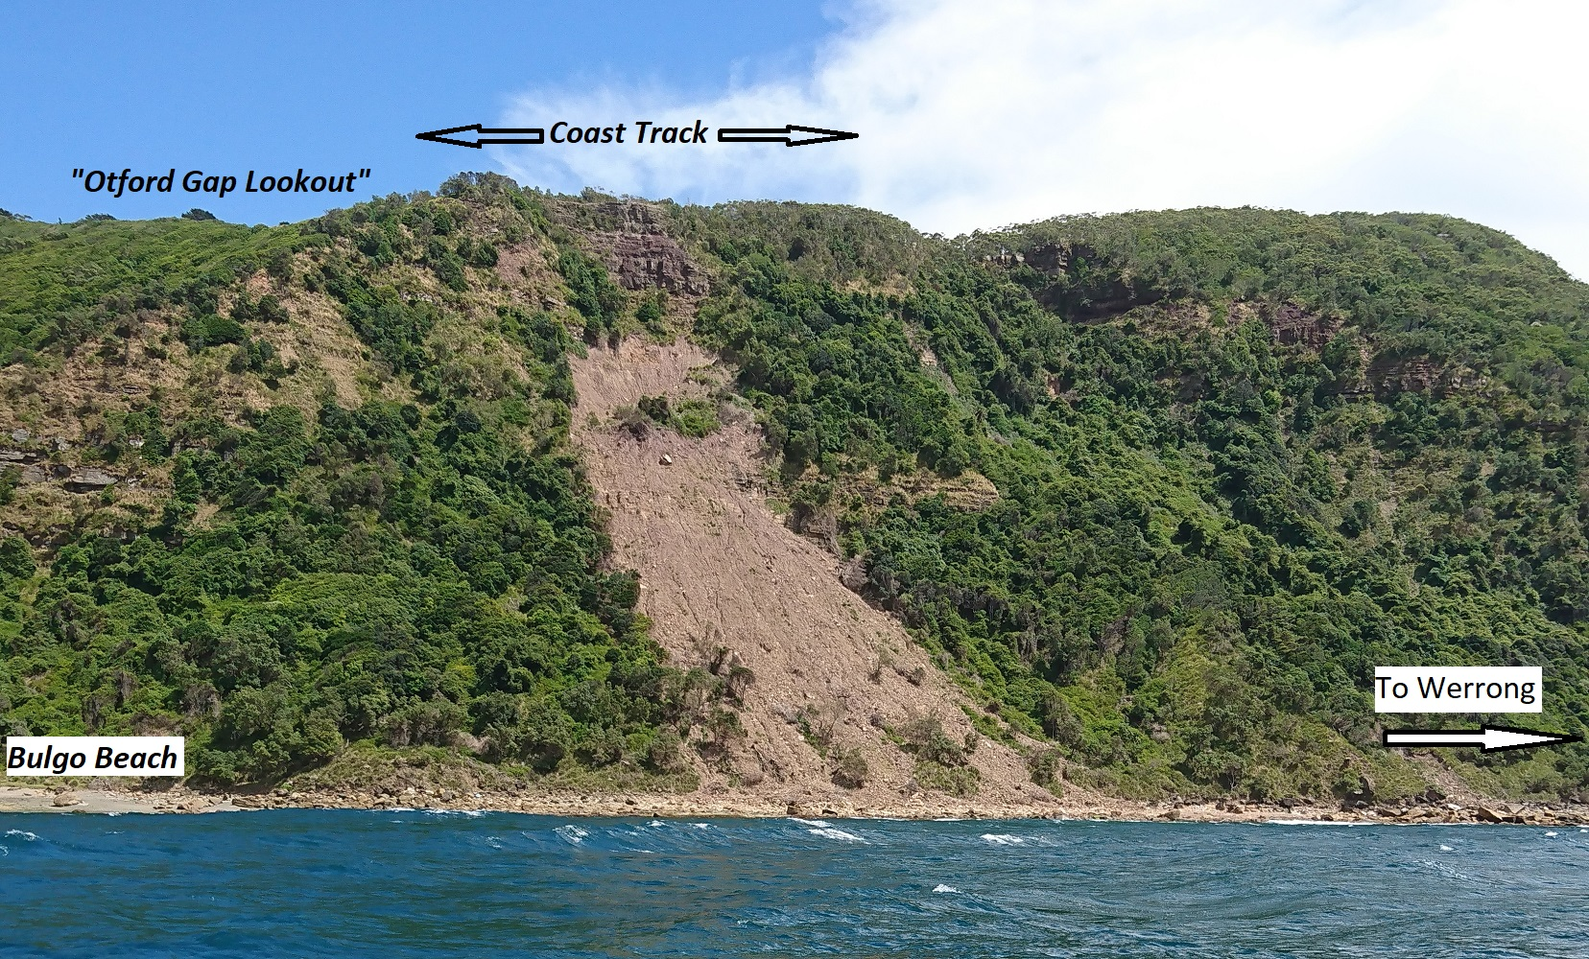

Presentation by Rhonda Daniels – Identifying Native Plants – tips and resources
- Rhonda gave an excellent presentation including guidance on:
  - How to interpret the scientific plant names from their latin base.
  - Books and websites for plant identification.

Other Business

- The meeting thanked Josie Piper for the many years that she has been bringing tea and refreshments to the FoR general meetings in the EEC.
- Recent Activities:
  - Bush regen has been continuing at Red Jacks and Middle Rill
    - At Middle Rill we found an area on the floor of the valley about the size of half a football pitch which had over 100 medium to small sized pampas grass. We sprayed the plants and will be back on 26th May to see what further treatment is required.
- Future activities:
  - Red Jacks Pt bush regen on Friday 19th May
  - Middle Rill bush regen on Friday 26th May
Meeting closed: at 6.05 p.m.

Next Committee Meeting
- Thursday 25 May 2023 at 4pm via Zoom.

Next General Meeting
- Thursday 22 June 2023 at 4 pm –EEC and Zoom

